Milestone 3 – Examples of some Sample “Special” Letters:

National Organizations and/or Multi-State Organizations:

Alarm Associations
Directory Publishers
Payphone Providers
National Public Safety Organizations
PSAP Coordinators
Elevator Regulatory Agencies
Seniors/AARP
TTY-Based Relay Providers & Assns
Telecom Associations
Tribal Associations

State/County Level Organizations:

Alarm Associations
Directory Publishers
Payphone Providers
Highway Call Box Operators
State 911 Agencies
911 County Coordinators
State PSAP Coordinators
Elevator Regulatory Agencies
Seniors/AARP
TTY-Based Relay Providers
Telecom Associations

ATTENTION FIRE AND ALARM PROVIDERS!

Effective October 24, 2021, MANDATORY 10-digit local dialing is required for all customers in the following area codes

Alaska | 907 | Minnesota | 218,952
Alabama | 251 | Mississippi | 662
Arkansas | 501 | Missouri | 314,417,660,816
Arizona | 480,520,928 | Montana | 406
California | 209,530,562,626,650,707,925 | Nevada | 775
 | 949,951 | New Hampshire | 603
Colorado | 719,970 | New Jersey | 856,908
Delaware | 302 | New Mexico | 505,575
Florida | 321(Brevard County), | New York | 516,607,716,845,914
 | 352,561,941 | North Carolina | 910
Georgia | 478,912 | Ohio | 440,513
Guam | 671 | South Dakota | 605
Hawaii | 808 | Tennessee | 731,865
Illinois | 309,618,708 | Texas | 254,361,409,806,830,915,9
Indiana | 219,574 | Vermont | 4802
Iowa | 319,515 | Virginia | 276,804
Kansas | 620,785 | Washington | 509
Kentucky | 859 | Wisconsin | 262,414,608,920
Louisiana | 337,504
Michigan | 616,810,906,989

Why is the local dialing plan changing?
On July 16, 2020, the FCC adopted an Order (FCC 20-100) approving 988 as the 3-digit abbreviated dialing code to reach the National Suicide Prevention Lifeline, starting July 16, 2022. Customers must continue to dial 1-800-273-TALK (8255) to reach the Lifeline until July 16, 2022.

The Order requires all telecommunications carriers, interconnected Voice over Internet Protocol (VoIP) providers, and one-way VoIP providers (covered providers) to make any network changes necessary to ensure that users can dial 988 to reach the existing National Suicide Prevention Lifeline by July 16, 2022. For 988 to work in the above area codes, 10-digit local dialing must first be implemented.

Does this apply to everyone in these area codes?
Yes. Implementation of this Order requires all covered providers to make 10-digit dialing or (1+ area + telephone depending on dialing plan) mandatory for all local calls in every entire area code listed above and shown in blue on the maps at the end of this letter because 988 is assigned to customers as a working prefix. Areas shown in yellow on the maps below are not affected by this change.

Why is 10-digit dialing going to be required in these area codes?
The FCC ordered that any area code that has the 988 prefix assigned and has 7-digit local dialing be transitioned to 10-digit local dialing or (1+ area + telephone depending on dialing plan) to ensure

everyone is able to reach the National Suicide Prevention Lifeline using the
3-digit 988 code.

Will everyone in the entire area codes have to dial 10 digits for local calls?
Yes. Every customer with a number from the above area codes will change to mandatory 10-digit dialing for local calls or (1+ area + telephone depending on dialing plan). Dialing 7 digits for local calls will be prohibited for all customers in the entire area code.

What will be the new dialing procedure?
To complete local calls, the new dialing procedure requires callers to dial the area code + telephone number. This means that all local calls in the entire area code that are currently dialed with 7 digits will need to be dialed using the area code + telephone number or (1+ area + telephone number depending on dialing plan).

When will the dialing change begin?
Beginning April 24, 2021, you should start dialing 10 digits (area code + telephone number) for all local calls. If you forget and dial just 7 digits, your call will still be completed.

When will the dialing change become mandatory?
Beginning October 24, 2021, you must dial 10 digits (area code + telephone number) for all local calls, including calls within the same area code. On and after this date, local calls dialed with only 7 digits may not be completed, and a recording will inform you that your call cannot be completed as dialed. If you get this recording, you must hang up and dial again using the area code with the 7-digit telephone number.

All Fire and Burglar Alarm Providers must have any necessary changes for alarm customers in these area codes completed by October 24, 2021. Such updates or reprogramming must occur between April 24, 2021 and October 24, 2021 (the permissive dialing period). Starting these efforts before April 24, 2021 may result in failed calls if permissive 10-digit dialing has not yet been implemented.

What other changes need to be made?
In addition to changing your dialing patterns, all services, automatic dialing equipment, or other types of equipment that are programmed to complete local calls using only 7 digit numbers will need to be reprogrammed to complete calls to 10 digit numbers. Some examples are:
- life safety systems or medical monitoring devices
- PBXs
- fax machines
- Internet dial-up numbers
- fire or burglar alarm and security systems or gates
- speed dialers
- mobile or other wireless phone contact lists
- call forwarding settings
- voicemail services, and other similar functions

Be sure to check your website, personal and business stationery, advertising materials, personal and business checks, contact information, your personal or pet ID tags, and other such items to ensure the area code is included.

What will remain the same?
- Your telephone number, including current area code, will not change.
- The price of a call, coverage area, or other rates and services will not change due to the dialing change.
- What is a local call now will remain a local call regardless of the number of digits dialed.
- You will continue to dial 1+ the area code + telephone number for all long-distance calls.
- You will continue to dial a prefix when dialing from a multi-line telephone system (e.g., in a hotel, office building, etc.) as required.
- You can still dial just three digits to reach 711 (relay services) and 911 (emergency services).
- If 211, 311, 411, 511, 611, or 811 are currently available in your community, continue to dial these codes with just three digits.
- The National Suicide Prevention Lifeline can still be reached by dialing 1-800-273-TALK (8255) even after the 988 code is in effect.

Will a caller be able to reach the National Suicide Prevention Lifeline by dialing 988 and no other digits when calling from a Multi-Line Telephone System (MLTS)?
No. Callers will still be expected to dial a prefix (such as “9”) first when dialing 988 from a multi-line telephone system (i.e., in a hotel, office building, etc.). The FCC Order declined to require multi-line telephone systems (MLTS) to allow callers to reach the Lifeline by dialing 988 and no other digits.
Still have questions?
Customers with questions about the dialing change should contact their local service provider, or they can visit the FCC website https://www.fcc.gov/suicide-prevention-hotline.

Alaska Alabama

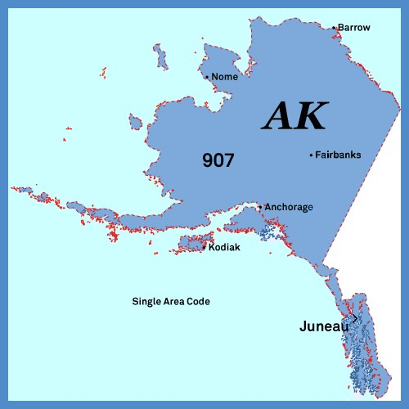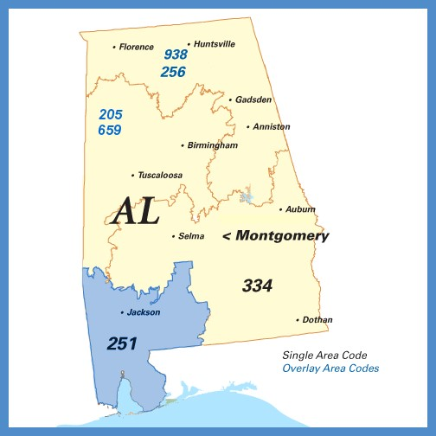

Arizona Arkansas

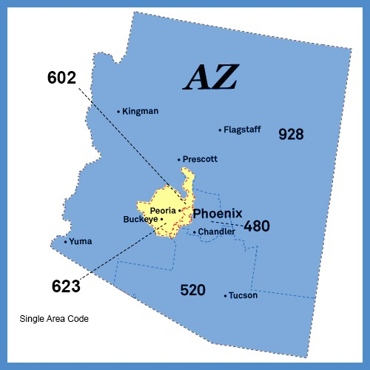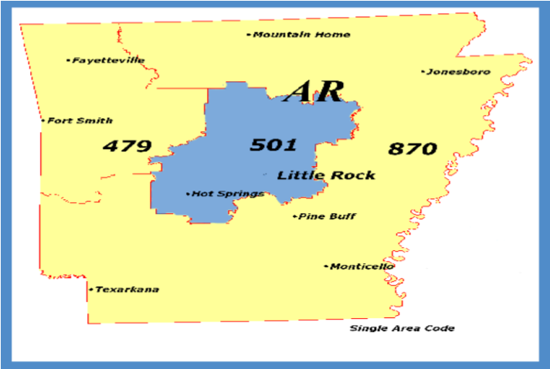

California 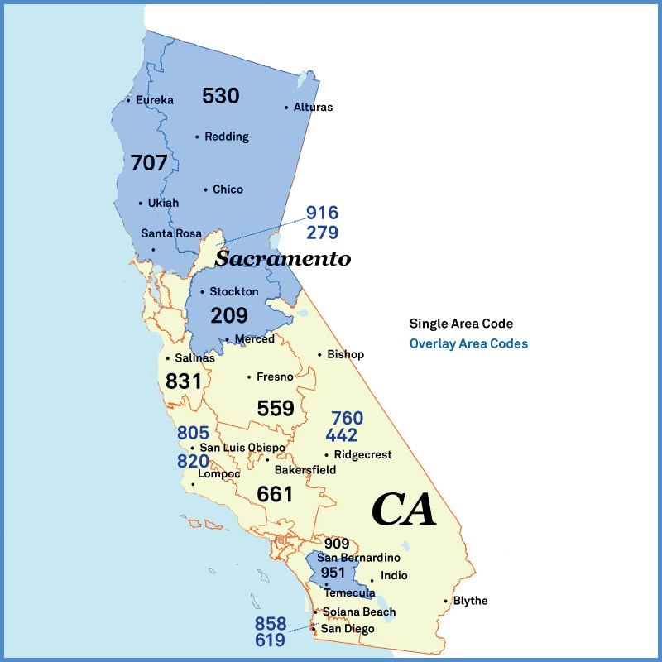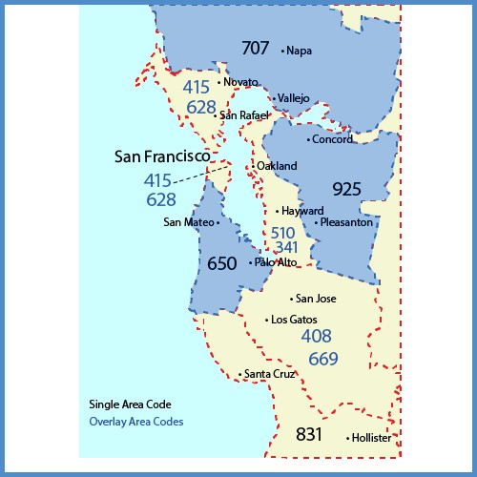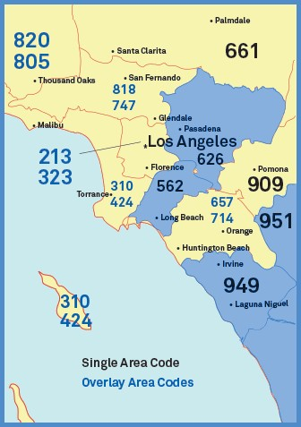

Colorado Delaware
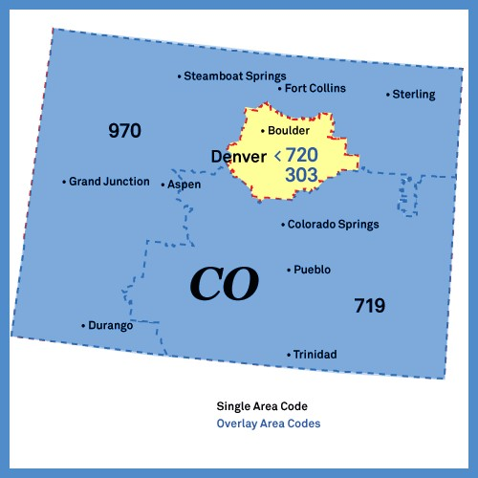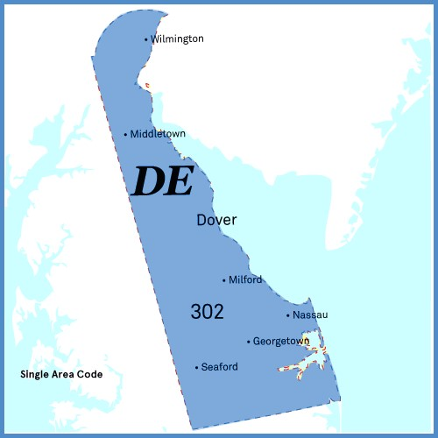

Florida Georgia

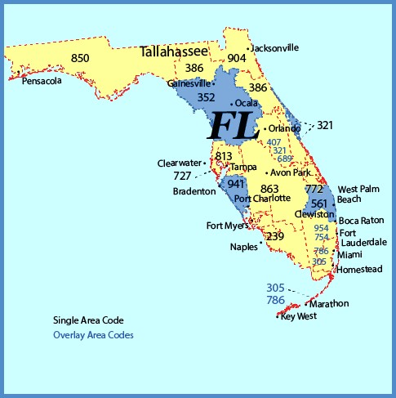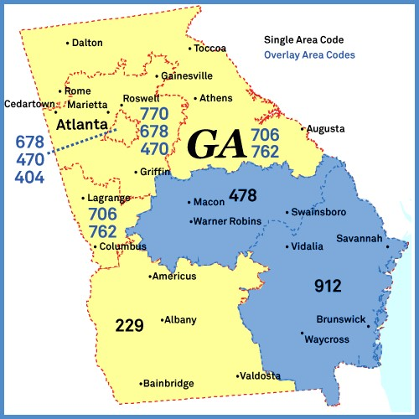

Guam Hawaii

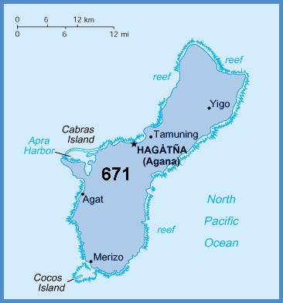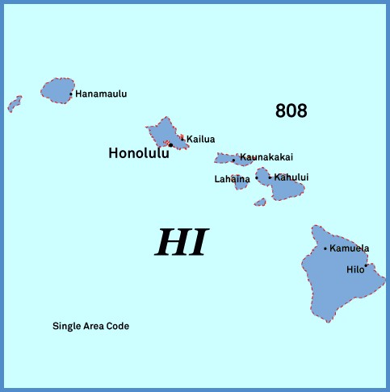

Illinois Indiana
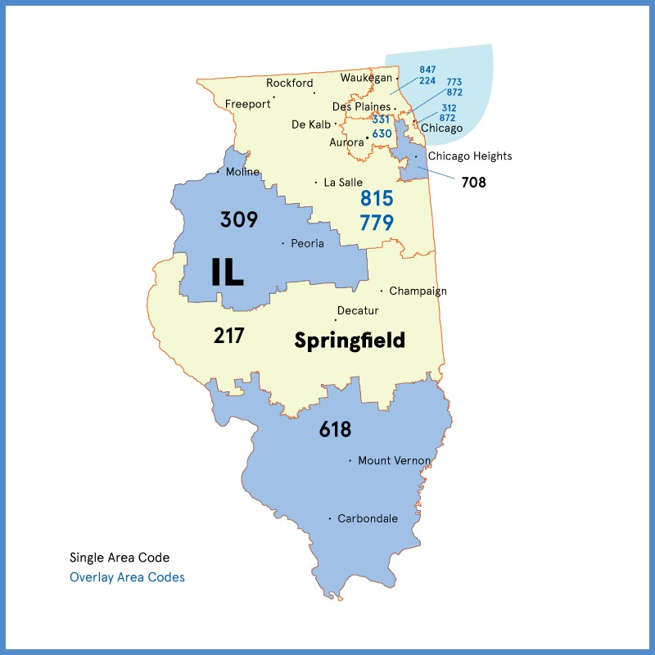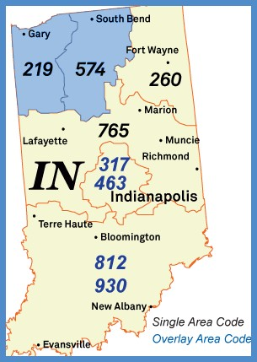

Iowa Kansas

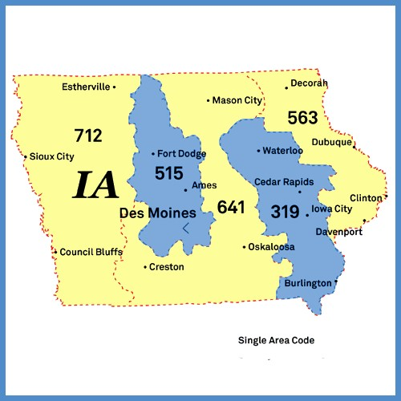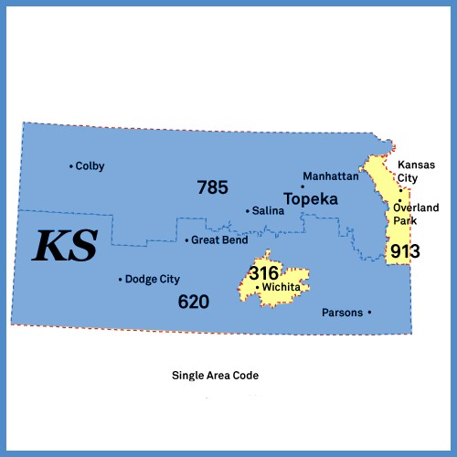

Kentucky Louisiana

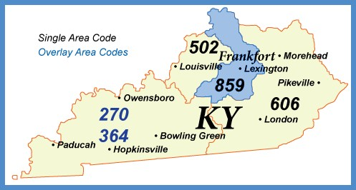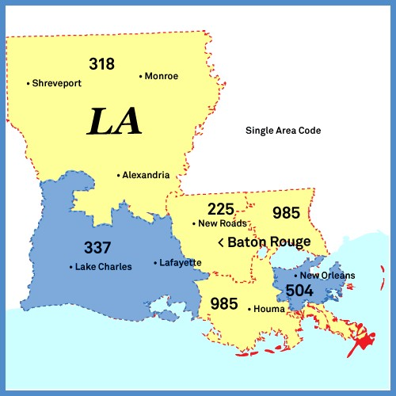

Michigan Minnesota

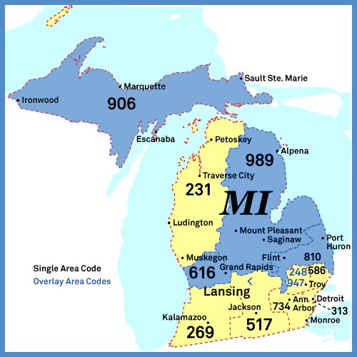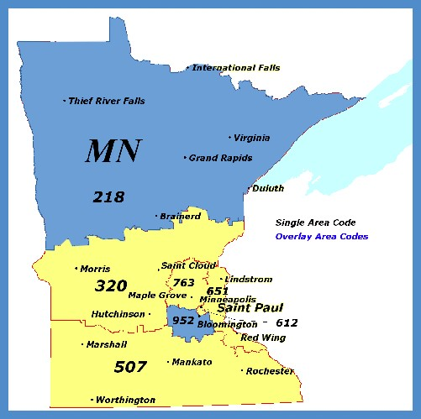

Mississippi Missouri

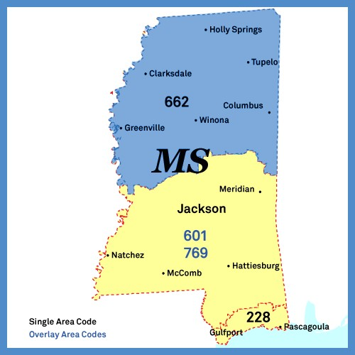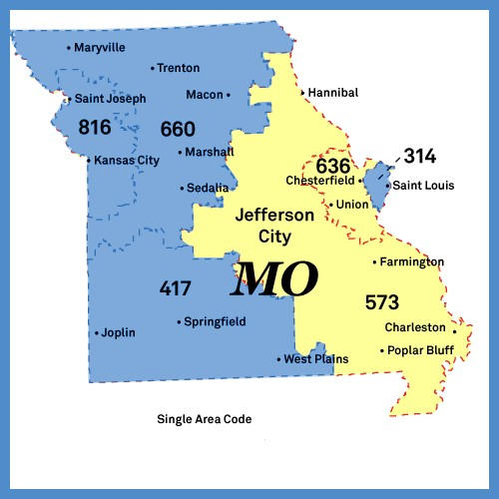

Montana Nevada

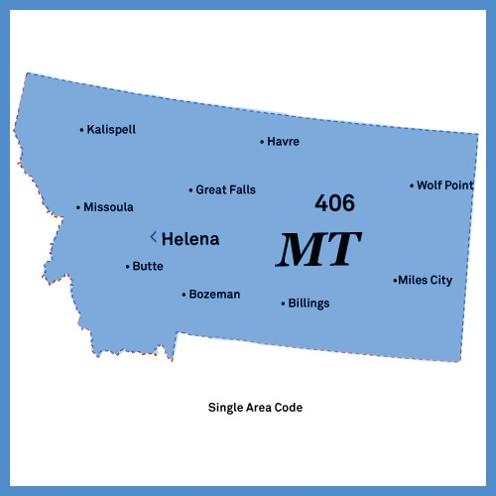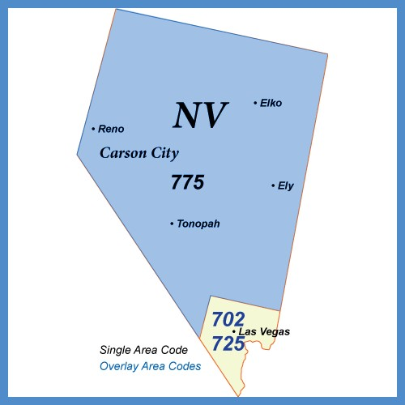

New Hampshire New Jersey

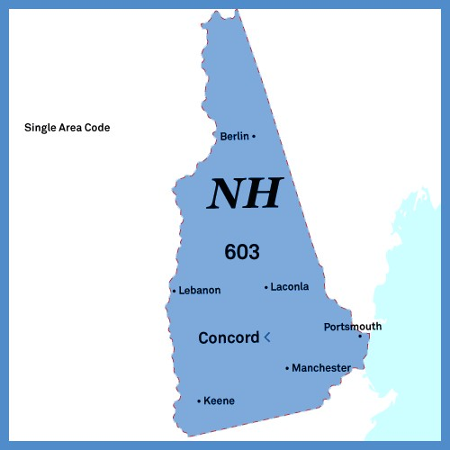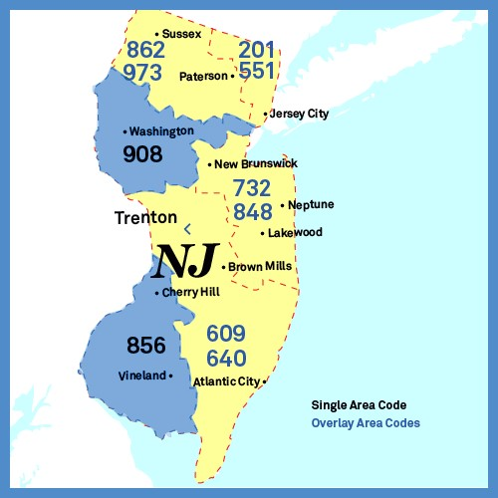

New Mexico New York

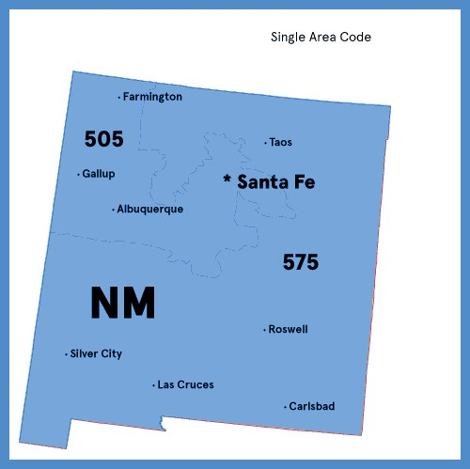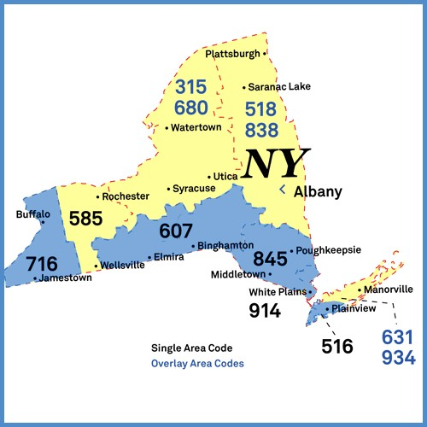

North Carolina

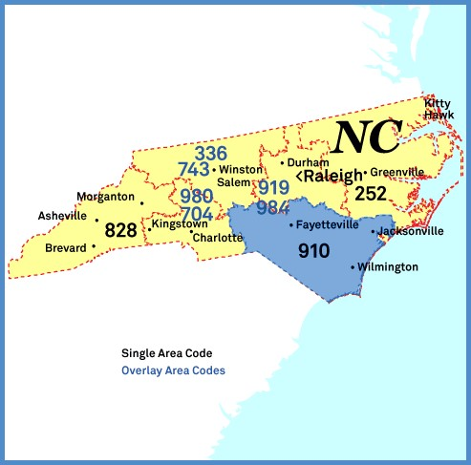

Ohio South Dakota

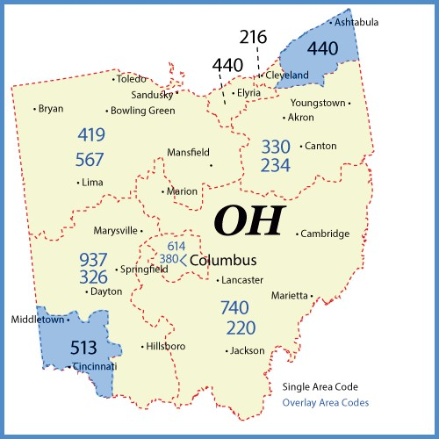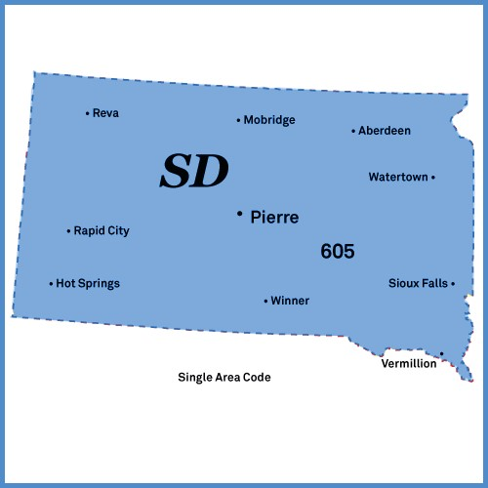

Tennessee Texas

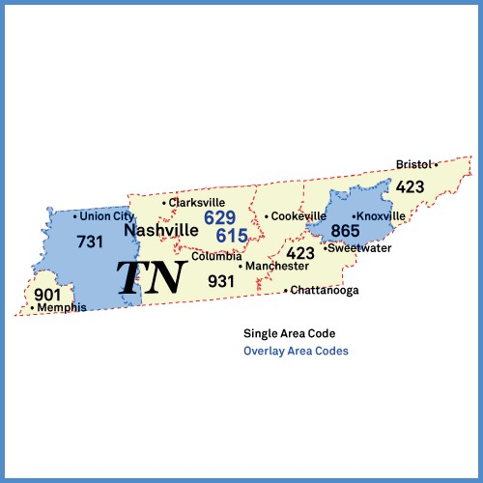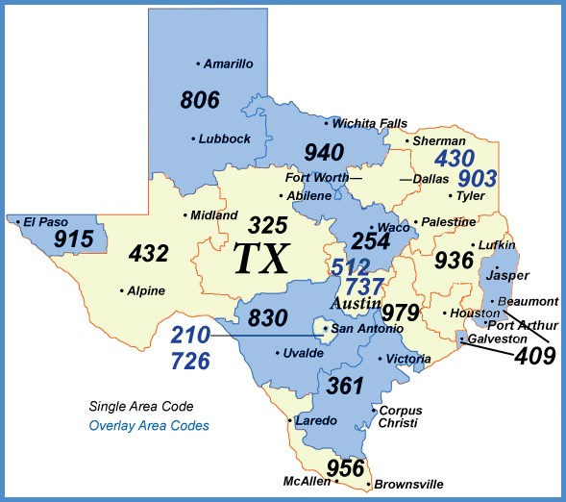

Vermont Virginia

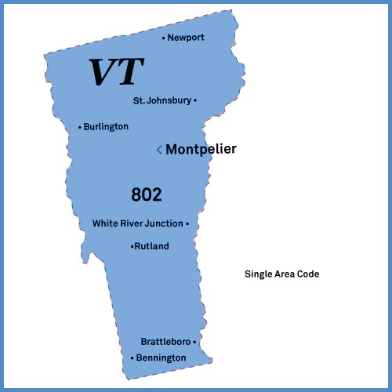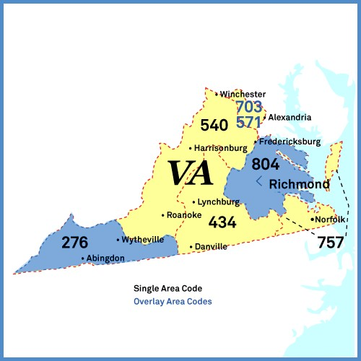

Washington Wisconsin

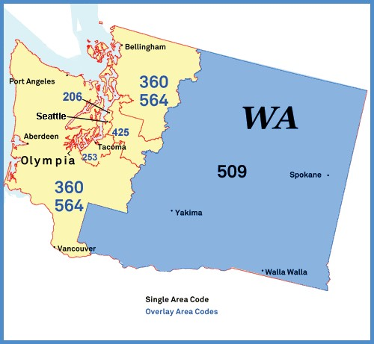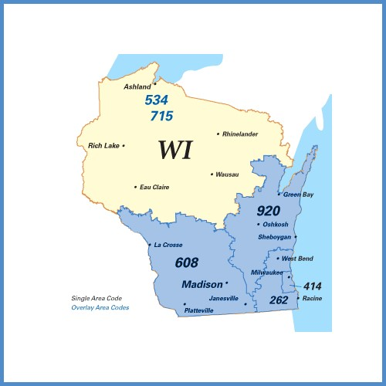

ATTENTION Customer-Owned Pay Telephone (COPT)
Providers!

Effective October 24, 2021, MANDATORY 10-digit local dialing is required for all customers in the (State/NPA) Area Code

Why is the local dialing plan changing?
On July 16, 2020, the FCC adopted an Order (FCC 20-100) approving 988 as the 3-digit abbreviated dialing code to reach the National Suicide Prevention Lifeline, starting July 16, 2022. Customers must continue to dial 1-800-273-TALK (8255) to reach the Lifeline until July 16, 2022.

The Order requires all telecommunications carriers, interconnected Voice over Internet Protocol (VoIP) providers, and one-way VoIP providers (covered providers) to make any network changes necessary to ensure that users can dial 988 to reach the existing National Suicide Prevention Lifeline by July 16, 2022. For 988 to work in the (State/NPA) area code, 10-digit local dialing must first be implemented.

Does this apply to (State)?
Yes. Implementation of this Order requires all covered providers to make 10-digit dialing mandatory for all local calls in the entire (State/NPA) area code.

Why is 10-digit dialing going to be required in this area code?
The FCC ordered that any area code that has the 988 prefix and has 7-digit local dialing be transitioned to 10-digit local dialing to ensure everyone is able to reach the National Suicide Prevention Lifeline using the 3-digit 988 code.

Will everyone in the (NPA) area code have to dial 10 digits for local calls?
Yes. Every customer with a number from the (NPA) area code will change to mandatory 10-digit dialing for local calls. Dialing 7 digits for local calls will be prohibited for all customers in the entire area code.

What will be the new dialing procedure?
To complete local calls, the new dialing procedure requires callers to dial the area code + telephone number. This means that all local calls in the entire (NPA) area code that are currently dialed with 7 digits will need to be dialed using the area code + telephone number.

When will the dialing change begin?
Beginning April 24, 2021, you should start dialing 10 digits (area code + telephone number) for all local calls. If you forget and dial just 7 digits, your call will still be completed.

When will the dialing change become mandatory?
Beginning October 24, 2021, you must dial 10 digits (area code + telephone number) for all local calls, including calls within the same area code. On and after this date, local calls dialed with only 7 digits may not be completed, and a recording will inform you that your call cannot be completed as dialed. If you get this recording, you must hang up and dial again using the area code with the 7-digit telephone number.

If COPT signage displayed on pay telephones in the affected area code instructs callers to dial 7 digits for all local calls, it must be updated to instruct callers to dial the area code and telephone number for all local calls. All COPT providers must make these signage changes no earlier than April 24, 2021 and no later than October 24, 2021.

What other changes need to be made?
In addition to changing your dialing patterns, all services, automatic dialing equipment, or other types of equipment that are programmed to complete local calls using only 7 digit numbers will need to be reprogrammed to complete calls to 10 digit numbers. Some examples are:

- life safety systems or medical monitoring devices
- PBXs
- fax machines
- Internet dial-up numbers
- fire or burglar alarm and security systems or gates
- speed dialers
- mobile or other wireless phone contact lists
- call forwarding settings
- voicemail services, and other similar functions

Be sure to check your website, personal and business stationery, advertising materials, personal and business checks, contact information, your personal or pet ID tags, and other such items to ensure the area code is included.

What will remain the same?
- Your telephone number, including current area code, will not change
- The price of a call, coverage area, or other rates and services will not change due to the dialing change
- What is a local call now will remain a local call regardless of the number of digits dialed
- You will continue to dial 1+ the area code + telephone number for all long-distance calls
- You will continue to dial a prefix when dialing from a multi-line telephone system (e.g., in a hotel, office building, etc.) as required
- You can still dial just three digits to reach 711 (relay services) and 911 (emergency services)
- If 211, 311, 411, 511, 611, or 811 are currently available in your community, continue to dial these codes with just three digits
- The National Suicide Prevention Lifeline can still be reached by dialing 1-800-273-8255 (TALK) even after the 988 code is in effect

When can I begin dialing 988 to reach the National Suicide Prevention Lifeline?
Beginning July 16, 2022, dialing “988” will route your call to the National Suicide Prevention Lifeline. Customers must continue to dial 1-800-273-8255 (TALK) to reach the Lifeline until July 16, 2022.

Still have questions?
Customers with questions about the dialing change should contact their local service provider, or they can visit the FCC website https://www.fcc.gov/suicide-prevention-hotline.

ATTENTION DIRECTORY PUBLISHERS!

Effective October 24, 2021, MANDATORY 10-digit local dialing is required for all customers in the (State/NPA) Area Code

Why is the local dialing plan changing?
On July 16, 2020, the FCC adopted an Order (FCC 20-100) approving 988 as the 3-digit abbreviated dialing code to reach the National Suicide Prevention Lifeline, starting July 16, 2022. Customers must continue to dial 1-800-273-TALK (8255) to reach the Lifeline until July 16, 2022.

The Order requires all telecommunications carriers, interconnected Voice over Internet Protocol (VoIP) providers, and one-way VoIP providers (covered providers) to make any network changes necessary to ensure that users can dial 988 to reach the existing National Suicide Prevention Lifeline by July 16, 2022. For 988 to work in the (State/NPA) area code, 10-digit local dialing must first be implemented.

Does this apply to (State)?
Yes. Implementation of this Order requires all covered providers to make 10-digit dialing mandatory for all local calls in the entire (State/NPA) area code.

Why is 10-digit dialing going to be required in this area code?
The FCC ordered that any area code that has the 988 prefix and has 7-digit local dialing be transitioned to 10-digit local dialing to ensure everyone is able to reach the National Suicide Prevention Lifeline using the 3-digit 988 code.

Will everyone in the (NPA) area code have to dial 10 digits for local calls?
Yes. Every customer with a number from the (NPA) area code will change to mandatory 10-digit dialing for local calls. Dialing 7 digits for local calls will be prohibited for all customers in the entire area code.

What will be the new dialing procedure?
To complete local calls, the new dialing procedure requires callers to dial the area code + telephone number. This means that all local calls in the entire (NPA) area code that are currently dialed with 7 digits will need to be dialed using the area code + telephone number.

When will the dialing change begin?
Beginning April 24, 2021, you should start dialing 10 digits (area code + telephone number) for all local calls. If you forget and dial just 7 digits, your call will still be completed.

When will the dialing change become mandatory?
Beginning October 24, 2021, you must dial 10 digits (area code + telephone number) for all local calls, including calls within the same area code. On and after this date, local calls dialed with only 7 digits may not be completed, and a recording will inform you that your call cannot be completed as dialed. If you get this recording, you must hang up and dial again using the area code with the 7-digit telephone number.

Telephone Directories covering any region in this area code must alert customers of the
dialing change to 10 digits (area code + telephone) for all local calls. Directories must be updated to reflect the new dialing procedure no earlier than April 24, 2021 and no later than October 24, 2021.

What other changes need to be made?
In addition to changing your dialing patterns, all services, automatic dialing equipment, or other types of equipment that are programmed to complete local calls using only 7 digit numbers will need to be reprogrammed to complete calls to 10-digit numbers. Some examples are:

- life safety systems or medical monitoring devices
- PBXs
- fax machines
- Internet dial-up numbers
- fire or burglar alarm and security systems or gates
- speed dialers
- mobile or other wireless phone contact lists
- call forwarding settings
- voicemail services, and other similar functions

Be sure to check your website, personal and business stationery, advertising materials, personal and business checks, contact information, your personal or pet ID tags, and other such items to ensure the area code is included.

What will remain the same?
- Your telephone number, including current area code, will not change
- The price of a call, coverage area, or other rates and services will not change due to the dialing change
- What is a local call now will remain a local call regardless of the number of digits dialed
- You will continue to dial 1+ the area code + telephone number for all long-distance calls
- You will continue to dial a prefix when dialing from a multi-line telephone system (e.g., in a hotel, office building, etc.) as required
- You can still dial just three digits to reach 711 (relay services) and 911 (emergency services)
- If 211, 311, 411, 511, 611, or 811 are currently available in your community, continue to dial these codes with just three digits
- The National Suicide Prevention Lifeline can still be reached by dialing 1-800-273-8255 (TALK) even after the 988 code is in effect

When can I begin dialing 988 to reach the National Suicide Prevention Lifeline?
Beginning July 16, 2022, dialing “988” will route your call to the National Suicide Prevention Lifeline. Customers must continue to dial 1-800-273-8255 (TALK) to reach the Lifeline until July 16, 2022.

Still have questions?
Customers with questions about the dialing change should contact their local service provider, or they can visit the FCC website https://www.fcc.gov/suicide-prevention-hotline.

ATTENTION 911 State/County Coordinators and PSAPs!

Effective October 24, 2021, MANDATORY 10-digit local dialing is required for all customers in the (State/NPA)Area Code

Why is the local dialing plan changing?
On July 16, 2020, the FCC adopted an Order (FCC 20-100) approving 988 as the 3-digit abbreviated dialing code to reach the National Suicide Prevention Lifeline, starting July 16, 2022. Customers must continue to dial 1-800-273-TALK (8255) to reach the Lifeline until July 16, 2022.

The Order requires all telecommunications carriers, interconnected Voice over Internet Protocol (VoIP) providers, and one-way VoIP providers (covered providers) to make any network changes necessary to ensure that users can dial 988 to reach the existing National Suicide Prevention Lifeline by July 16, 2022. For 988 to work in the (State/NPA) area code, 10-digit local dialing must first be implemented.

Does this apply to (State)?
Yes. Implementation of this Order requires all covered providers to make 10-digit dialing mandatory for all local calls in the entire (State/NPA) area code.

Why is 10-digit dialing going to be required in this area code?
The FCC ordered that any area code that has the 988 prefix and has 7-digit local dialing be transitioned to 10-digit local dialing to ensure everyone is able to reach the National Suicide Prevention Lifeline using the 3-digit 988 code.

Will everyone in the (NPA) area code have to dial 10-digits for local calls?
Yes. Every customer with a number from the (NPA) area code will change to mandatory 10-digit dialing for local calls. Dialing 7 digits for local calls will be prohibited for all customers in the entire area code.

What will be the new dialing procedure?
To complete local calls, the new dialing procedure requires callers to dial the area code + telephone number. This means that all local calls in the entire (NPA) area code that are currently dialed with 7- digits will need to be dialed using the area code + telephone number.

When will the dialing change begin?
Beginning April 24, 2021, you should start dialing 10-digits (area code + telephone number) for all local calls. If you forget and dial just 7-digits, your call will still be completed.

When will the dialing change become mandatory?
Beginning October 24, 2021, you must dial 10-digits (area code + telephone number) for all local calls. On and after this date, local calls dialed with only 7-digits may not be completed, and a recording will inform you that your call cannot be completed as dialed. If you get this recording, you must hang up and dial again using the area code with the 7-digit telephone number.

How does this affect providers of PSAP services and equipment?
All local calls in the (NPA) area code that are currently dialed with 7 digits will need to be dialed using area code + telephone number. All PSAP equipment, such as speed dialers and call forwarding equipment with a number from the (NPA) area code and programmed to dial only 7 digits must be updated or reprogrammed to dial 10 digits (area code + telephone number) for all local calls in the (NPA) area code. Such updates or reprogramming must occur between April 24, 2021 and October 24, 2021 (the permissive dialing period). Starting these efforts before April 24, 2021 may result in 10-digit calls not being completed (if permissive 10-digit dialing has not yet been implemented). And on and after October 24, 2021, 7-digit calls may not be completed.

Any necessary changes for PSAPs in this area code

must be completed by October 24, 2021.

What other changes need to be made?
In addition to changing your dialing patterns, all services, automatic dialing equipment, or other types of equipment that are programmed to complete local calls using only 7 digit numbers will need to be reprogrammed to complete calls to 10-digit numbers. Some examples are:

- life safety systems or medical monitoring devices
- PBXs
- fax machines
- Internet dial-up numbers
- fire or burglar alarm and security systems or gates
- speed dialers
- mobile or other wireless phone contact lists
- call forwarding settings
- voicemail services, and other similar functions

Be sure to check your website, personal and business stationery, advertising materials, personal and business checks, contact information, your personal or pet ID tags, and other such items to ensure the area code is included.

What will remain the same?
- Your telephone number, including current area code, will not change
- The price of a call, coverage area, or other rates and services will not change due to the dialing change
- What is a local call now will remain a local call regardless of the number of digits dialed
- You will continue to dial 1+ the area code + telephone number for all long-distance calls
- You will continue to dial a prefix when dialing from a multi-line telephone system (i.e., in a hotel, office building, etc.) as required
- You can still dial just three digits to reach 711 (relay services) and 911 (emergency services)
- If 211, 311, 411, 511, 611, or 811 are currently available in your community, continue to dial these codes with just three digits
- The National Suicide Prevention Lifeline can still be reached by dialing 1-800-273-8255 (TALK) even after the 988 code is in effect

When can I begin dialing 988 to reach the National Suicide Prevention Lifeline?
Beginning July 16, 2022, dialing “988” will route your call to the National Suicide Prevention Lifeline. Customers must continue to dial 1-800-273-8255 (TALK) to reach the Lifeline until July 16, 2022.

Still have questions?
Customers with questions about the dialing change should contact their local service provider, or they can visit the FCC website https://www.fcc.gov/suicide-prevention-hotline.

