Frequently Asked Questions (FAQS)

Mandatory 10-Digit (or 1+10-digit) Local Dialing will be required for all customers in the area codes listed below for the National Suicide Prevention Lifeline 988 three-digit code

Why is the 988-prefix changing to a three-digit abbreviated dialing code? | On July 16, 2020, the FCC adopted an Order (FCC 20-100) approving the designation of 988 as the three-digit abbreviated dialing code for the National Suicide Prevention Lifeline, requiring all telecommunications carriers, interconnected Voice over Internet Protocol (VoIP) providers, and one-way VoIP providers (covered providers) to make any network changes necessary to ensure that users can dial 988 to reach the existing National Suicide Prevention Lifeline: 1-800-273-8255 (TALK) starting July 16, 2022.
What is the impact of making the 988 a three-digit dialing code? | In the area codes where the 988 is a working prefix, local calls will have to be dialed using all 10-digits of the phone number, even if they are in the same area code. To complete all local calls, you will need to dial the area code + telephone number (or 1+ area code + telephone number depending on dialing plan). This applies to all calls within these area codes that are currently dialed with seven-digits. In all there are 82 area codes in 36 states that are impacted by this change.
What states/area codes are impacted by this Order? | STATE AREA CODES AFFECTED  Alaska 907  Alabama 251  Arkansas 501  Arizona 480, 520, 928  California 209, 530, 562, 626, 650, 707, 925, 949, 951  Colorado 719, 970  Delaware 302  Florida 321 (Brevard County only), 352, 561, 941  Georgia 478, 912  Guam 671  Hawaii 808  Illinois 309, 618, 708  Indiana 219, 574  Iowa 319, 515  Kansas 620, 785  Kentucky 859  Louisiana 337, 504  Michigan 616, 810, 906, 989  Minnesota 218, 952  Mississippi 662  Missouri 314, 417, 660, 816  Montana 406  Nevada 775  New Hampshire 603  New Jersey 856, 908  New Mexico 505, 575  New York 516, 607, 716, 845, 914  North Carolina 910  Ohio 440, 513  South Dakota 605  Tennessee 731, 865  Texas 254, 361, 409, 806, 830, 915, 940  Vermont 802  Virginia 276, 804  Washington 509  Wisconsin 262, 414, 608, 920
Will everyone in the area codes above have to dial 10-digits (or 1+10-digits) for a local call or just the people with 988 numbers? | Yes. Every customer throughout the area codes listed above will change to mandatory 10-digit (or 1+10-digit) dialing for local calls. Dialing seven-digits for local calls will be prohibited for all customers in the entire area code.  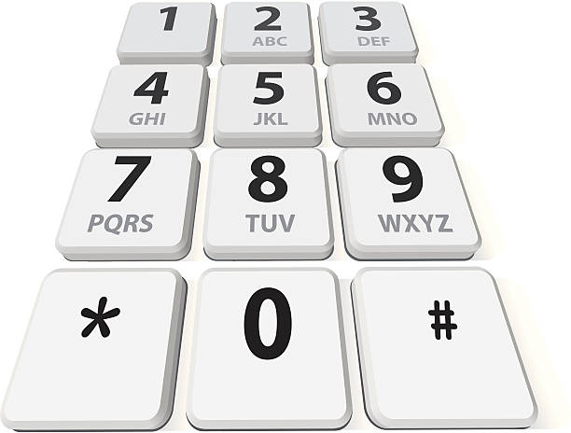
Why is 10-digit dialing going to be required in these area codes? | The FCC ordered that these area codes must be transitioned to 10-digit (or 1+10-digit) local dialing to ensure everyone is able to reach the National Suicide Prevention Lifeline using the three-digit 988 code.
How is this going to happen? | The North American Numbering Plan Administrator (NANPA) developed, based on input from covered service providers, an implementation schedule that will allow all covered providers to meet the transition deadline in an efficient manner that best accounts for the challenges each covered provider faces.
Will I have to change my phone number? | No. One of the reasons for changing to 10-digit local dialing is to avoid the need to change people’s telephone numbers.
Will I be able to begin 10-digit (or 1+10-digit) local dialing before it is required? | Yes. Beginning April 24, 2021, if you have a telephone number in one these area codes, you should start dialing 10-digits (area code + telephone number) or 1+10-digit (1+area code+telephone number depending on dialing plan) for all local calls. If you forget and dial just seven-digits, your call will still be completed.
When will 10-digit local dialing become mandatory? | Beginning October 24, 2021, if you have a number in one of these area codes, you must dial 10-digits (area code + telephone number) or 1+10 digits (1+area code+telephone number depending on dialing plan) for all local calls. On and after this date, local calls dialed with only seven-digits may not be completed, and a recording will inform you that your call cannot be completed as dialed. If you get this recording, you must hang up and dial again using the area code with the seven-digit telephone number.
What other changes need to be made? | In addition to changing your dialing patterns, all services, automatic dialing equipment, or other types of equipment that are programmed to complete local calls using only seven-digit numbers will need to be reprogrammed to complete calls to 10-digit numbers. Some examples are:  - life safety systems or medical monitoring devices  - PBXs  - fax machines  - Internet dial-up numbers  - fire or burglar alarm and security systems or gates  - speed dialers  - mobile or other wireless phone contact lists  - call forwarding settings  - voicemail services and other similar functions  Be sure to check your website, personal and business stationery, advertising materials, personal and business checks, contact information, your personal or pet ID tags, and other such items to ensure the area code is included.
What will stay the same? | - Your telephone number, including current area code, will not change  - The price of a call, coverage area, or other rates and services will not change due to the dialing change  - What is a local call now will remain a local call regardless of the number of digits dialed  - You will continue to dial 1+ the area code + telephone number for all long-distance calls  - You will continue to dial a prefix (such as “9”) when dialing from a multi-line telephone system (i.e., in a hotel, office building, etc.) as required  - You can still dial just three digits to reach 711 (relay services) and 911 (emergency services)  - Any 211, 311, 411, 511, 611, or 811 services available in your community can still be reached by dialing their three-digit codes  - The National Suicide Prevention Lifeline can still be reached by dialing 1-800-273-8255 (TALK) even after the 988 code is in effect.
When can I begin dialing “988” to reach the National Suicide Prevention Lifeline? | Beginning July 16, 2022, dialing “988” will route your call to the National Suicide Prevention Lifeline. Customers should continue to dial 1-800-273-8255 (TALK) to reach the Lifeline until July 16, 2022.
Who can I contact if I still have questions? | If you have any questions regarding information provided in this notice, please contact your local service provider for more information. You can also visit the FCC website at https://www.fcc.gov/suicide-prevention-hotline.

Following are maps for all of the affected states. Areas in blue represent area codes changing to 10-digit (or 1+10-digit) dialing. Areas in yellow are not affected by this change.

Alaska Alabama
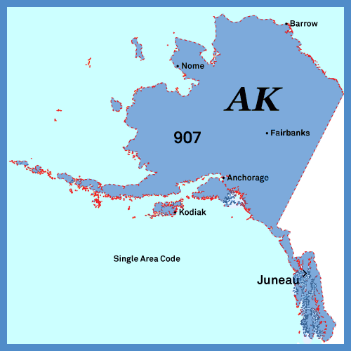

Arizona Arkansas
California
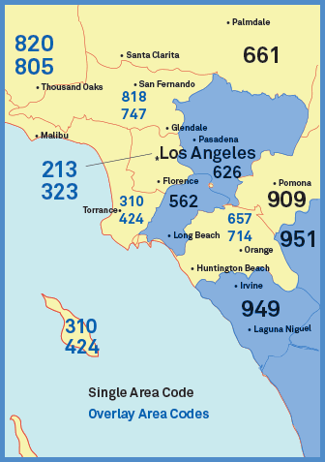

Colorado Delaware

Florida Georgia

Guam Hawaii

Illinois Indiana

Iowa Kansas

Kentucky Louisiana

Michigan Minnesota

Mississippi Missouri

Montana Nevada

New Hampshire New Jersey

New Mexico New York

North Carolina Ohio

South Dakota Tennessee

Texas Vermont

Virginia Washington

Wisconsin

